A

Project Report on

Company System –

Organization Workflow Mapping



Submitted to:

**Department of Computer Engineering Cusrow Wadia Institute of Technology, Pune – 411001**

By:-

1. Sarvesh Anand Mankar 194009
2. Gourav Balaji Suram 194028
3. Umer MohmmadRafiqu Shaikh 194032

A

Project Report on

Company System –

Organization Workflow Mapping



Under the guidance of

Prof. R. P. Shete

Submitted By:-

1. Sarvesh Anand Mankar 194009
2. Gourav Balaji Suram 194028
3. Umer MohmmadRafiqu Shaikh 194032

Department of Computer Engineering Cusrow Wadia Institute of Technology, Pune – 411001

(2021 - 2022)

**CERTIFICATE**



This is to certify that the below mentioned third year diploma students have carried out the project work on “Company System- Organization Workflow Mapping” in the department of computer engineering, Cusrow Wadia Institute of Technology, Pune-1. They have completed this project work under my guidance and in satisfactory manner in July 2021 of third year diploma.

1. Sarvesh Anand Mankar 194009
2. Gourav Balaji Suram 194028
3. Umer MohmmadRafiqu Shaikh 194032

Computer Engineering students have successfully completed project on “Skill Space – Training and Competency Mapping” towards the fulfilment of their Diploma in Computer Engineering in academic year 2020-2021.

Date : 16/07/2022

Prof. R.P. Shete Dr. A. S. Chandak Prof. V.R. Rao

Guide H.O.D Computer Dept. Principal

1. **Introduction**

In this world of growing technologies everything has been computerized. Most of the daily routine tasks needs to be automated to increase the proficiency in the work. With large number of demands and working opportunities the data size has been increased. This there is a need of a system which can handle the data efficiently. This project simplifies the task to maintain each and every working group of the organization. It stores the data efficiently and makes sure that it is used effectively.

The Company Management System has been developed to override the problems prevailing in the practicing manual system. This software is supported to eliminate and, in some cases, reduce the hardships faced by the organization. Moreover, this system is designed for the particular need of the organization to carry out operations in a smooth and efficient manner.

The application is reduced as much as possible to avoid errors while entering the data. It also provides error while entering invalid data. No formal knowledge is needed for the user to use this system. Thus, by this all it proves its user friendly.

The Company Management System will have certain roles that will perform the Top-Level Management tasks, certain roles for performing Mid-Level Management tasks and Employee role which enhance the integrity of the company. The tasks are assigned and completed in a agile manner.

1. **Acknowledgement**

“No one achieves success does so without acknowledging the help of others. The wise and confident acknowledge this help with gratitude.”

~Alfred North Whitehead

We take this opportunity in expressing the fact that this project report is the result of incredible amount of encouragement, co-operation and moral support that we have received from our beloved teachers, mentors and colleagues.

We are privileged to present the project report on “Company Management System – Organization Workflow Mapping” and to express our deep regards towards those who have offered their valuable time and guidance in our hour of need because when any work is to be completed successfully it should be supported and guided by knowledgeable mentors.

We are highly indebted to “Dr. A. S. Chandak (H.O.D Computer Dept.)‟ and our project guide Prof. R. P. Shete for her guidance and constant supervision as well as providing necessary information regarding project and also for their support in completing project.

We would like to express our gratitude towards our sponsors and members of computer engineering department for their kind co-operation and encouragement which helped us in successful completion of this project.

1. Sarvesh A. Mankar 194009
2. Gourav B. Suram 194028
3. Umer M. Shaikh 194032
4. **Abstract**

“Company Management is like juggling three balls: time, cost and quality. Company management is like a troupe of circus performers standing in a circle, each juggling three balls and swapping balls from time to time.”

~ G. Reiss

There are in numerous of activities which needs to be performed for the smooth flow of the company. Handling these tasks manually would take lot of time and will affect the outcome adversely. “Time is Money”, which brings our Company System into picture. This project helps to reduce the manual tasks, and computerizes the various assests that will boost the company’s progress.

The Project will allow admin to add new employees, managing their work, adding new client projects, assigning work to employees, marking employee attendance, managing Project files & reports, salary management, invoice and receipt generation, etc. which makes the whole organization managed effectively by using a single application.

Every organization, whether big or small, have multiple assets which need to be managed properly in order to achieve maximum profits, therefore we designed exclusive Company Management System that adapt to all the managerial and daily routine requirements. This is designed to assist in strategic planning and will help you ensure that your organization is able to achieve its goals. This system ultimately allows you to better manage resources.

1. **Keywords**

Employee Management System, Training Programs, Hiring System, Evaluation Platform, Employee Assessment System, Project Management System, Client Management System, Finance Structure, Invoice generation, Report generation, Attendance System, Salary System, Responsive Pages, Database Management.

1. **Presently Available System**

A Company not only needs automation but also to maintain the workflow and make reliable updates to maintain the stage as planned. Having a distinctive software helps to boost the enterprise tasks resulting into the growth of the firm. The identification of the needs and implementation of the current and future demands are essential for any organization.

The current system includes bunch of manual tasks which eventually slows down the time period of the firm. Having an automation system will help to do the frequent tasks with much swifter and robustness.

Some of the renowned Company System software are Zoho One, Scoro, StudioCloud, Odoo, BaseCamp, NetSuit, Clarizen, etc. and their common features are:

1. User-Friendly Interface.
2. Mobile Accessibility.
3. Structured Task Planning.
4. Task Scheduling.
5. Task Tracking.
6. Task Communication.
7. Integrated Time Tracking.
8. Collaborative Features.
9. **Need of Such System**

A good change is the one that happens gradually - the business and employees also need some time to adjust to the newly implemented system. The manual system will reduce the efficiency in the communication which can create complication in the updates of the projects. As a result, a responsible firm needs management system to track the activities and improvise them to maximize the profits and to stand against stiff competition in the market.

Benefits of Company System

1. **Enhanced management** - well-organised and systematised business processes.
2. **Increased employee engagement** - each member of staff is actively involved in the decision-making processes thanks to an excellent information flow.
3. **Collaboration** - cross-functional teams working along to achieve specific company goals.
4. **Simplicity** - things are operating smoothly, easily and efficiently; the system is user-friendly, which makes navigating between different screens seamless and effortless for anyone with access rights.
5. **Costs** - an all-in-one business management solution will save you money that you would otherwise have to pay for each individual piece of software providing various services.
6. **Accessibility** - allows you to access the parts of the system that you need regardless of time or place and, at the same time, prevents those with no access rights from entering; it simply matches access to responsibilities and ensures that the information stays secure.
7. **Avoiding errors** - with business management software, you only introduce the information once and the system will take care of the rest; this [automation](https://cio-wiki.org/wiki/Business_Management_System_(BMS)) leaves no room for any error whatsoever.

**7. Detailed Problem Statement**

To create a better environment and workspace for each client as well as the employee is vitally important to run the routine cycle of the firm.

Company system offers all the required feature required by a firm to perform the ongoing tasks and create a convalescent domain. Main aim of the Company System is to keep healthy workplace.

1. **Hardware and Software Requirements**

**Hardware Requirements**

* Processor : Intel i5 5th Generation
* Cores : 4
* Processor Speed : 3.0 GHz
* RAM : 4 Gigabytes
* SSD : 1024 Megabytes
* Speed : 1.10 GHz
* Clock Speed : 2.4 GHz
* Graphics : Intel Iris XE

**Software Requirements**

* Operating System : Windows 11 / Linux
* Application : Xampp, Apache Server
* Tools and utilities : PHP Server, Git log
* IDE : VSCode, NVIM, Vi, Sublime
* Front End : HTML, CSS, JS
* Framework : Bootstrap
* JavaScript Libraries : jQuery UI, jQuery Migrate, Data-Tables.

1. **System Design**
   1. **ER Diagram**

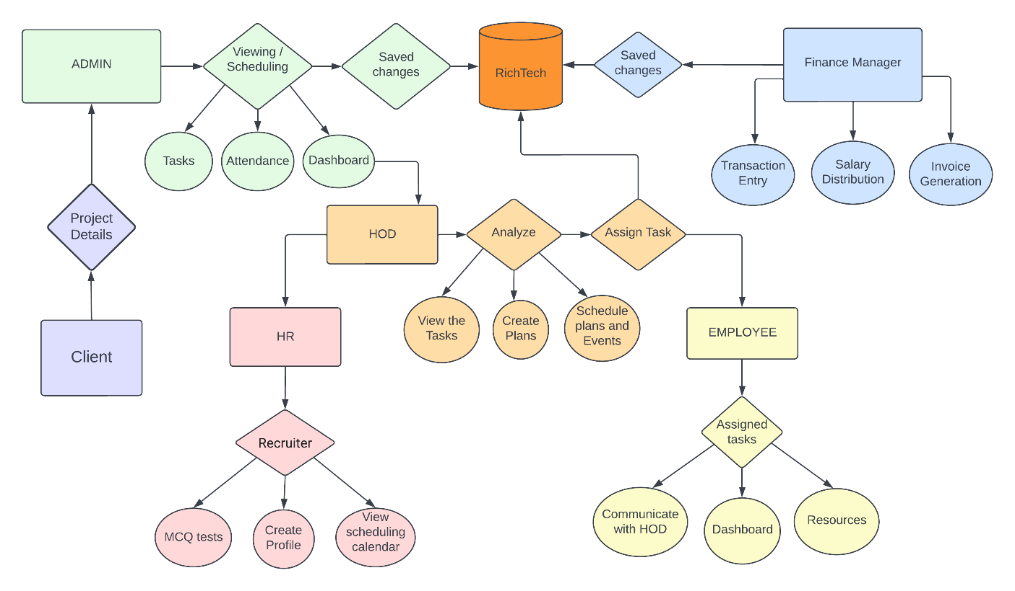

* 1. **Use Case Diagram**
     1. **Employee**

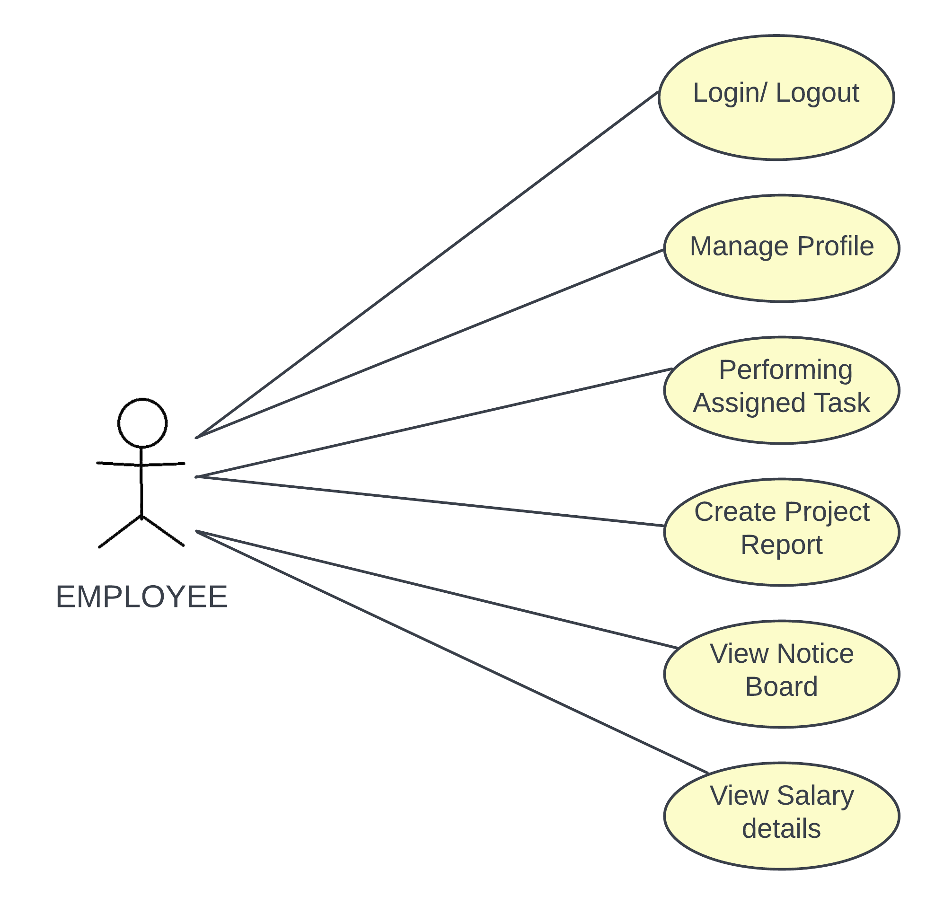

* + 1. **H.O.D and H.R**

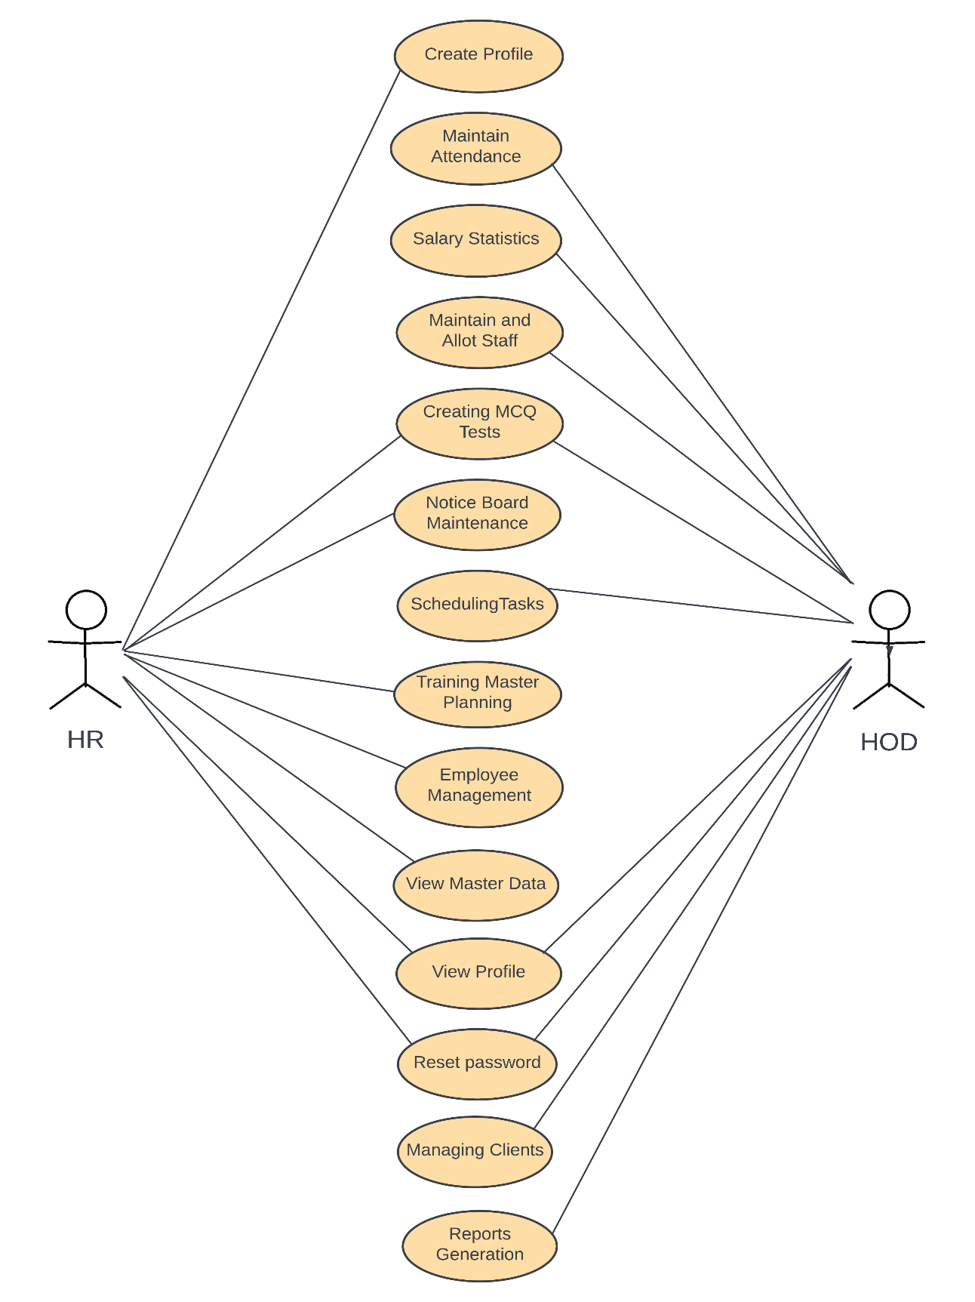

* 1. **Class Diagram**

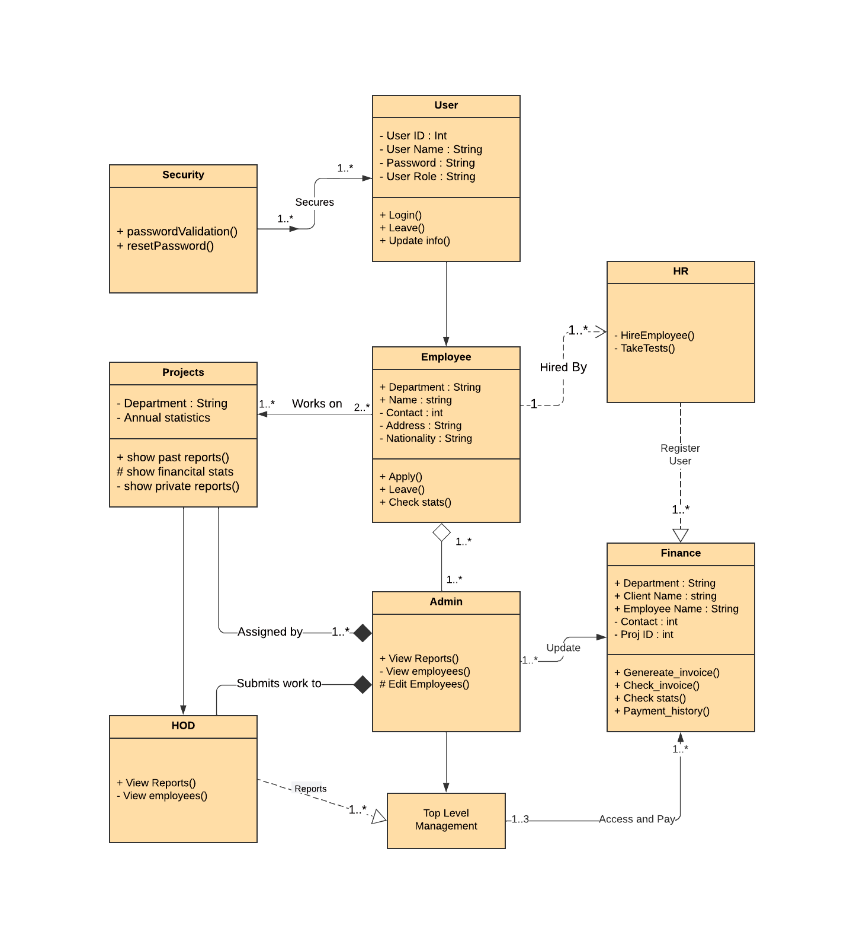

* 1. **Activity Diagram**

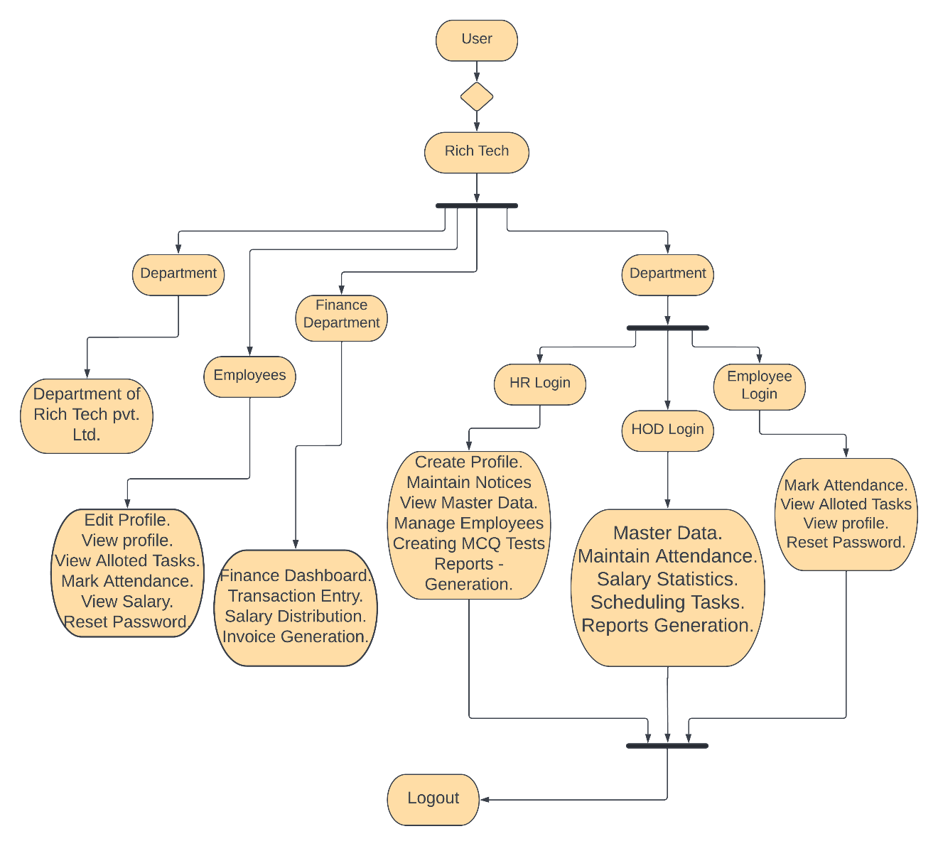

* 1. **Data Flow Diagram**
     1. **Level 0**

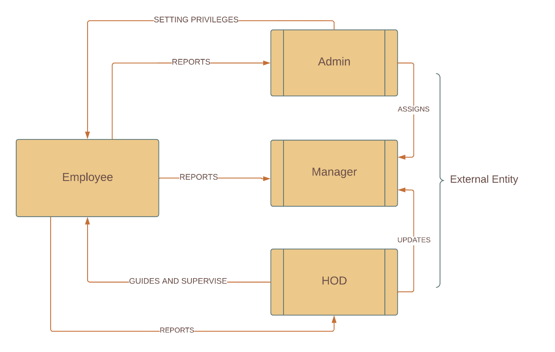

* + 1. **Level 1**

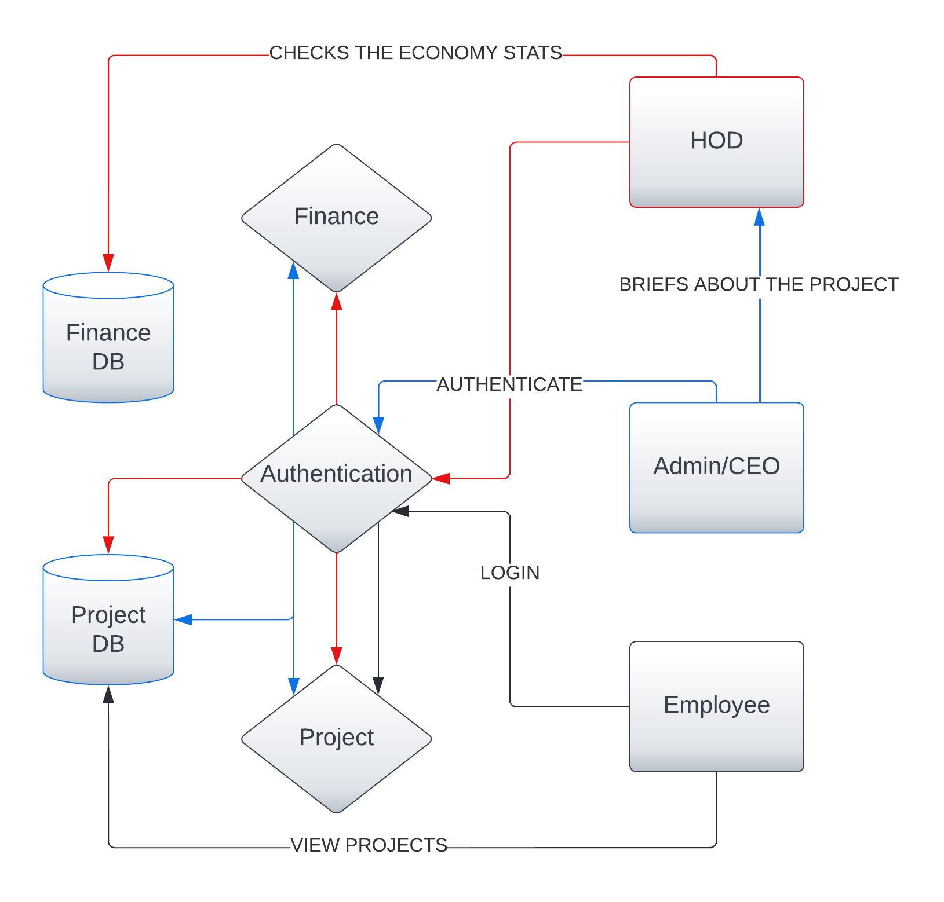

* + 1. **Level 2**

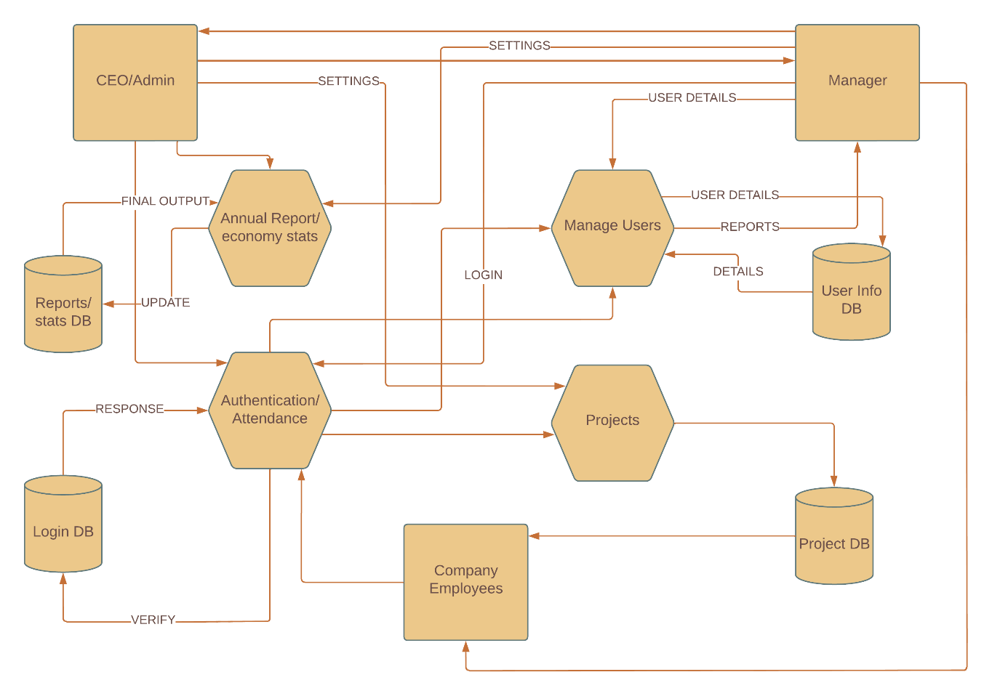

* 1. **Flow Diagram**

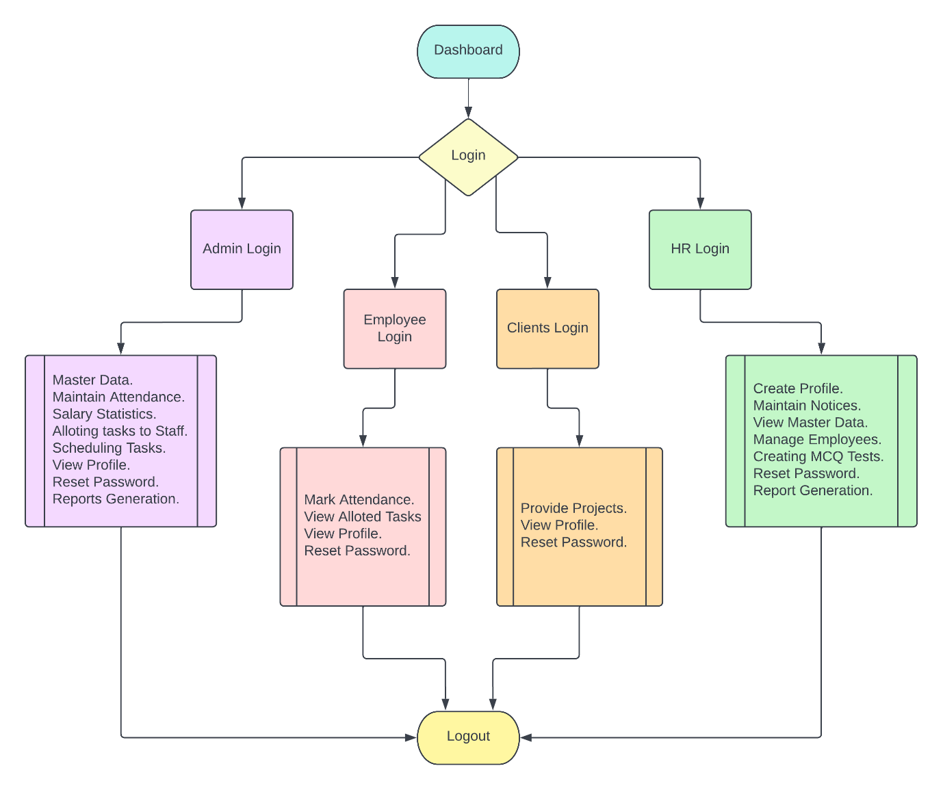

* 1. **Sequence Diagram**

